
Touchstones
Netcards

Respect Netcards with Text

Baby HRJ
Balloon Heart HRJ
Black Lives Matter HRJ
Broken Doll HRJ

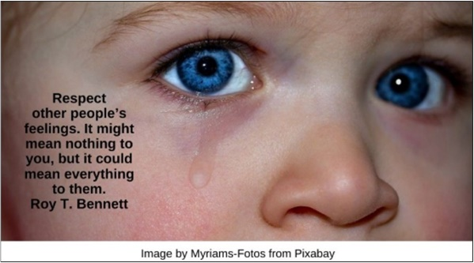

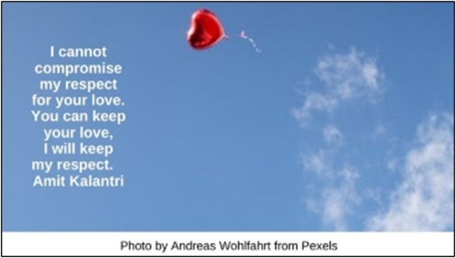

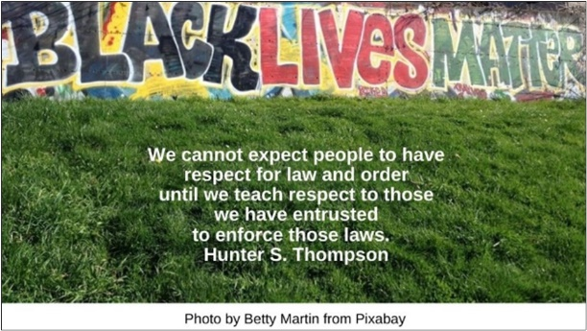

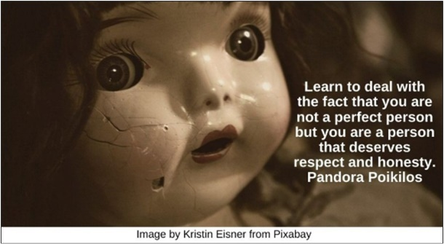
Chain HRJ
Character HRJ
Children HRJ
Emily Post HRJ

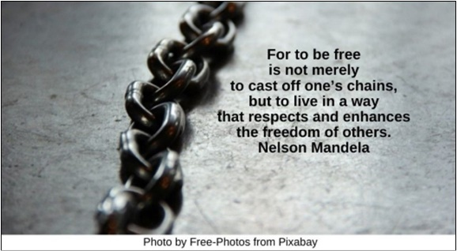

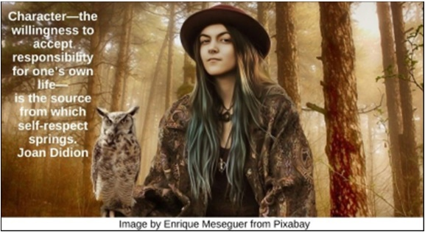

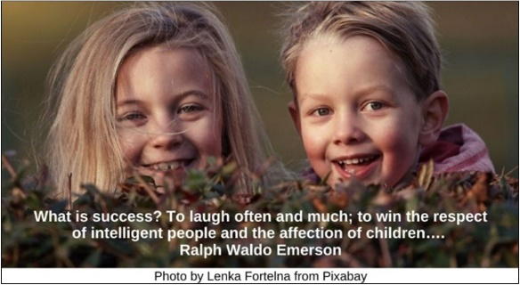

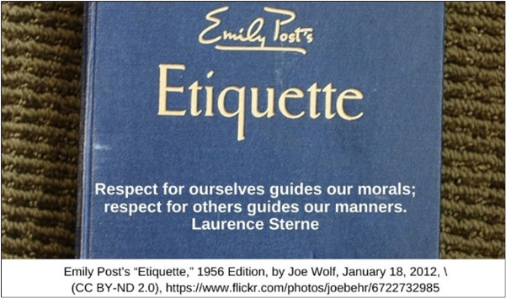

George Floyd HRJ
High School HRJ
Justice HRJ
Landscape HRJ

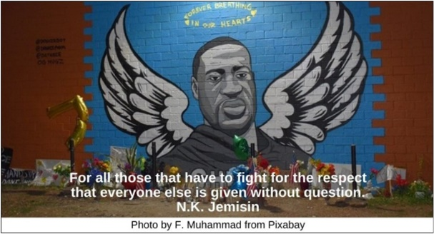

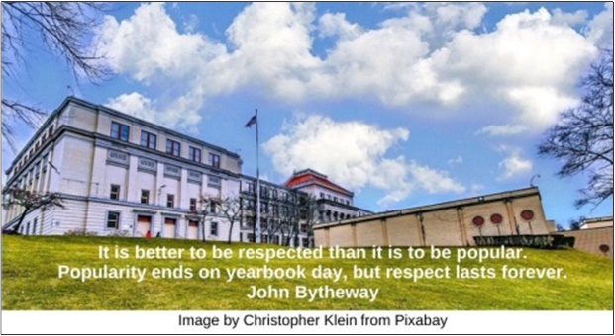

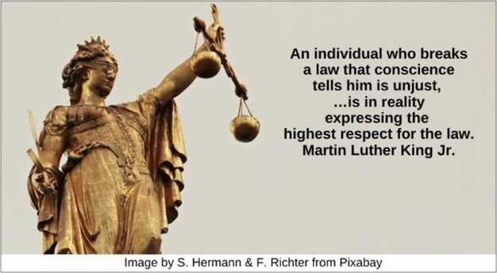

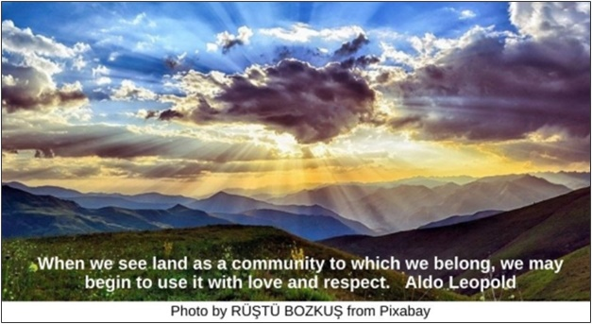

Look Inward HRJ
Love HRJ
Moonlight HRJ
Nature HRJ

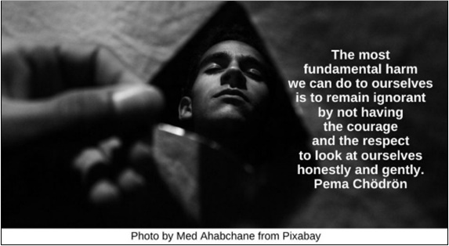

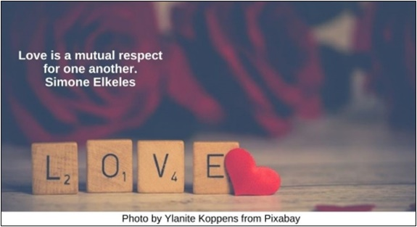

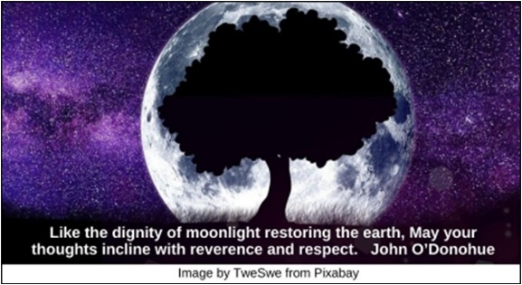

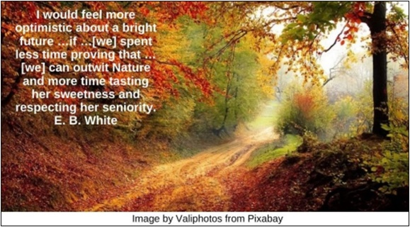

No HRJ
Peace HRJ
Prada HRJ
Prayer HRJ

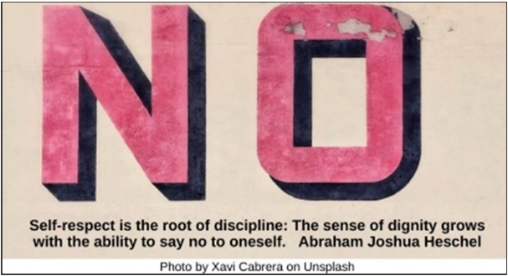

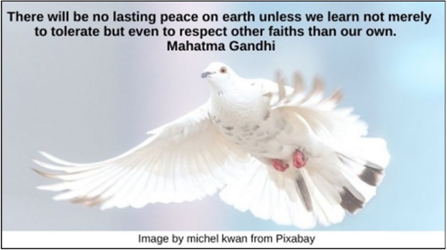

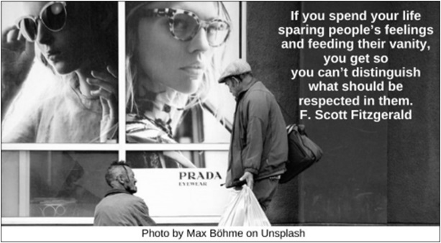

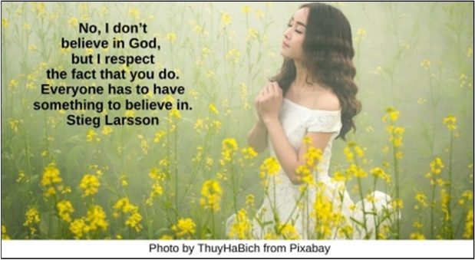

Pride HRJ
Respect HRJ
Searching HRJ
Seasons HRJ

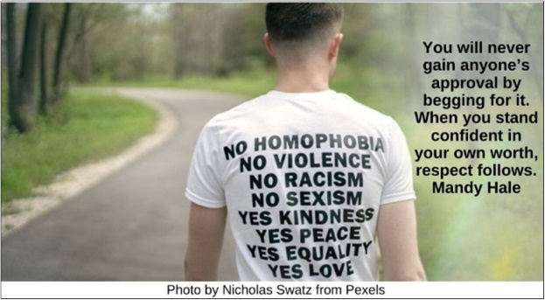

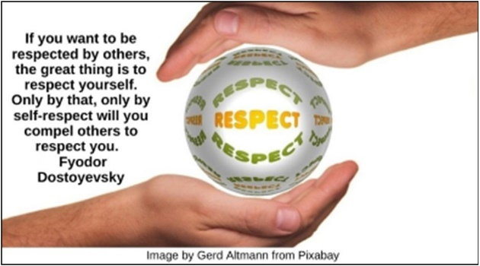

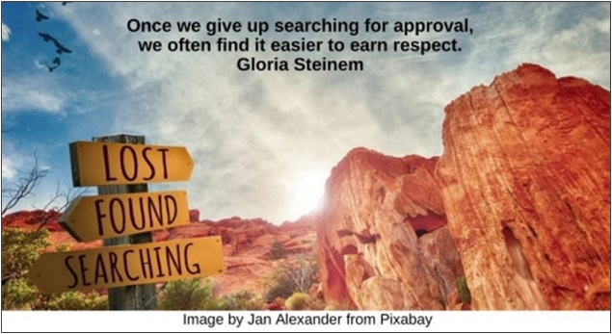

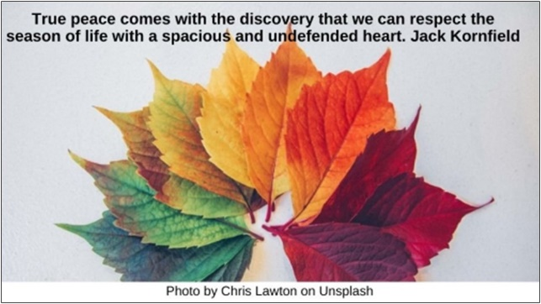

Street HRJ
Student HRJ
Teacher HRJ
The Sea HRJ

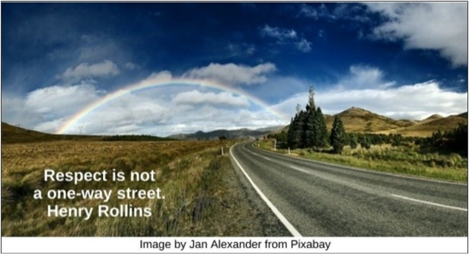

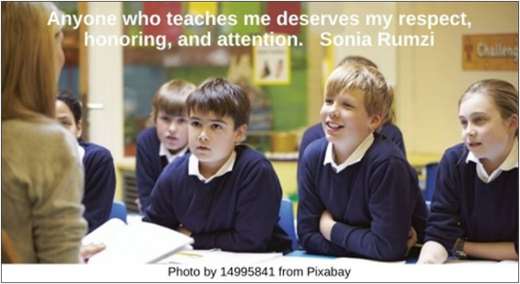

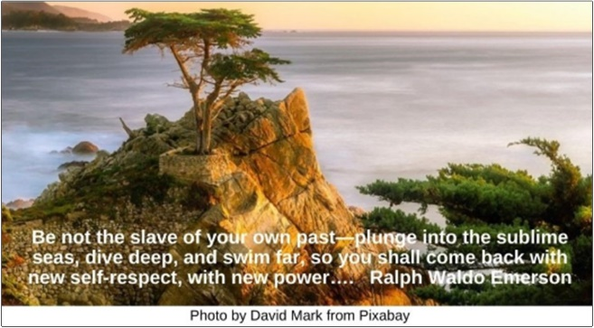

Tuesday HRJ
US Capital HRJ
World HRJ

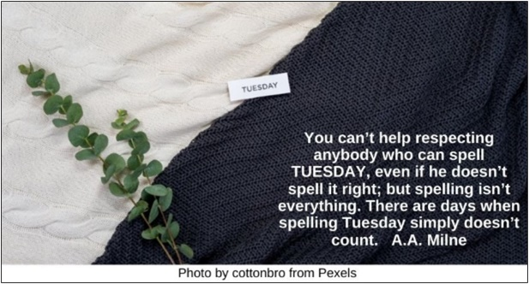

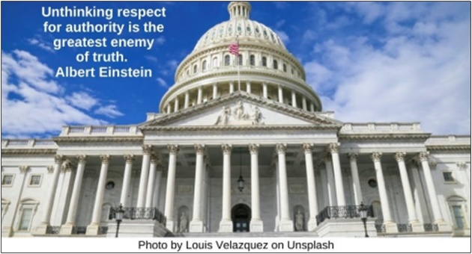

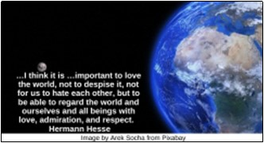

Text of Quotes

Baby HRJ
Respect other people’s feelings. It might mean nothing to you, but it could mean everything to them. Roy T. Bennett

Balloon Heart HRJ
I cannot compromise my respect for your love. You can keep your love, I will keep my respect. Amit Kalantri

Black Lives Matter HRJ
We cannot expect people to have respect for law and order until we teach respect to those we have entrusted to enforce those laws. Hunter S. Thompson

Broken Doll HRJ
Learn to deal with the fact that you are not a perfect person but you are a person that deserves respect and honesty. Pandora Poikilos

Chain HRJ
For to be free is not merely to cast off one’s chains, but to live in a way that respects and enhances the freedom of others. Nelson Mandela

Character HRJ
Character—the willingness to accept responsibility for one’s own life—is the source from which self-respect springs. Joan Didion

Children HRJ
What is success? To laugh often and much; to win the respect of intelligent people and the affection of children…. Ralph Waldo Emerson

Emily Post HRJ
Respect for ourselves guides our morals; respect for others guides our manners. Laurence Sterne
George Floyd HRJ
For all those that have to fight for the respect that everyone else is given without question. N.K. Jemisin

High School HRJ
It is better to be respected than it is to be popular. Popularity ends on yearbook day, but respect lasts forever. John Bytheway

Justice HRJ
An individual who breaks a law that conscience tells him is unjust, …is in reality expressing the highest respect for the law. Martin Luther King Jr.

Landscape HRJ
When we see land as a community to which we belong, we may begin to use it with love and respect. Aldo Leopold

Look Inward HRJ
The most fundamental harm we can do to ourselves is to remain ignorant by not having the courage and the respect to look at ourselves honestly and gently. Pema Chödrön

Love HRJ
Love is a mutual respect for one another. Simone Elkeles

Moonlight HRJ
Like the dignity of moonlight restoring the earth, May your thoughts incline with reverence and respect. John O’Donohue

Nature HRJ
I would feel more optimistic about a bright future …if …[we] spent less time proving that … [we] can outwit Nature and more time tasting her sweetness and respecting her seniority. E. B. White

No HRJ
Self-respect is the root of discipline: The sense of dignity grows with the ability to say no to oneself. Abraham Joshua Heschel

Peace HRJ
There will be no lasting peace on earth unless we learn not merely to tolerate but even to respect other faiths than our own. Mahatma Gandhi

Prada HRJ
If you spend your life sparing people’s feelings and feeding their vanity, you get so you can’t distinguish what should be respected in them. F. Scott Fitzgerald

Prayer HRJ
No, I don’t believe in God, but I respect the fact that you do. Everyone has to have something to believe in. Stieg Larsson

Pride HRJ
You will never gain anyone’s approval by begging for it. When you stand confident in your own worth, respect follows. Mandy Hale

Respect HRJ
If you want to be respected by others, the great thing is to respect yourself. Only by that, only by self-respect will you compel others to respect you. Fyodor Dostoyevsky

Searching HRJ
Once we give up searching for approval, we often find it easier to earn respect. Gloria Steinem

Seasons HRJ
True peace comes with the discovery that we can respect the seasons of life with a spacious and undefended heart. Jack Kornfield

Street HRJ
Respect is not a one-way street. Henry Rollins

Student HRJ
The secret of education lies in respecting the pupil. Ralph Waldo Emerson

Teacher HRJ
Anyone who teaches me deserves my respect, honoring and attention. Sonia Rumzi

The Sea HRJ
Be not the slave of your own past—plunge into the sublime seas, dive deep, and swim far, so you shall come back with new self-respect, with new power…. Ralph Waldo Emerson

Tuesday HRJ
You can’t help respecting anybody who can spell TUESDAY, even if he doesn’t spell it right; but spelling isn’t everything. There are days when spelling Tuesday simply doesn’t count. A.A. Milne

US Capital HRJ
Unthinking respect for authority is the greatest enemy of truth. Albert Einstein

World HRJ
…I think it is …important to love the world, not to despise it, not for us to hate each other, but to be able to regard the world and ourselves and all beings with love, admiration, and respect. Hermann Hesse

